

**MCA Semester – III**

**Front End Development Project**

|  |  |
| --- | --- |
| **Name** | **RUTHU . M . PATIL** |
| **USN** | **221VMTR02224** |
| **Elective** | **FULL STACK DEVELOPMENT** |
| **Date of Submission** | **20/12/2023** |



**Front End Development Project - Report**

Project Report submitted to Jain Online (Deemed-to-be University) as part of the course “Front End Development Project”

**Master of Computer Applications**

*Submitted by*

**RUTHU M PATIL**

USN

**221VMTR02224**

*Under the*

*guidance of*

(Faculty-JAIN Online)

**DECLARATION**

I, *Ruthu.M.Patil,* hereby declare that this Project Report has been prepared by me under the guidance of *Faculty name.* I declare that this Project is towards the partial fulfilment of the credit requirement for the course “Front End Development Project,” which is part of the Master of Computer Applications degree given by Jain University, Bengaluru. I declare that the work done by me towards this Project is original in nature and is my own contribution.

Place: Bangalore *Ruthu.M.Patil*

Date: 20/12/2023 *221VMTR02224*

**CERTIFICATE**

This is to certify that the Project report submitted by Mr./Ms. *Ruthu.M.Patil* bearing *221VMTR02224* on the title **“Front End Development Project”**is a record of project work done by him/ her during the academic year 2023-24 under my guidance and supervision in partial fulfillment of Master of Computer Applications.

Place: Bangalore

Date: *Faculty Guide*

**ACKNOWLEDGEMENT**

I would like to convey my heartfelt appreciation to all those who have played a crucial role in the successful culmination of my research project. Their guidance, support, and encouragement have been invaluable throughout this undertaking.

To begin, I extend sincere thanks to Mr. Alex Fummy, serving as my Organization Guide. His expert insights and consistent support proved indispensable in comprehending the practical aspects of the project, ultimately shaping its direction and execution.

I am profoundly grateful to Mr. George Mummy, our University Official, for his unwavering encouragement and support. His belief in the project's significance served as a motivating force, propelling me to strive for excellence in accordance with the esteemed standards set by our institution.

Special acknowledgment goes to Mr. Selx Gummy, my Faculty Guide, for his mentorship and scholarly advice. His expertise and guidance significantly contributed to the depth and quality of my research.

I also express my gratitude to the entire faculty whose valuable feedback and suggestions played a pivotal role in refining my understanding and approach to the research topic. Furthermore, I appreciate my classmates for their encouragement, engaging discussions, and steadfast support throughout this transformative journey. Their diverse perspectives and collaborative spirit have been enriching.

Lastly, I extend my sincere appreciation to my family and friends for their unwavering support and understanding during this academic pursuit.

*Ruthu.M.Patil*

*221VMTR02224*

**EXECUTIVE SUMMARY**

The project's objective was to develop an easily navigable travel website, featuring a dynamic homepage with engaging visuals and a clear navigation menu. The website incorporated various sections, including travel booking, attractive package showcases, service highlights, a captivating gallery, and company information. Users could seamlessly choose destinations, book travel, and explore services such as hotels and safety guides

The package gallery utilized card formats, displaying images, destination names, brief descriptions, USD prices, ratings, and booking options. The Services section emphasized amenities like Affordable Hotels and Food & Drinks. The Gallery section, incorporating engaging design elements such as hover transformations, showcased appealing photos of travel experiences. The "About Us" segment provided insights into the company's background and establishment.

Moreover, the website featured user-friendly registration and login functionalities with proper validations. It was deployed on GitHub for accessibility. The success of the project can be attributed to collaborative efforts, meticulous planning, and a dedicated focus on creating an immersive and efficient travel website interface.

**TABLE OF CONTENTS**

|  |  |
| --- | --- |
| **Title** | **Page Nos.** |
| Executive Summary | 06 |
| Introduction | 08 |
| Objectives | 09 |
| Project Description | 10 |
| Additional Features | 12 |
| Flowchart | 13 |
| Coding | 14 |
| Output | 46 |
| Validation | 50 |
| Conclusion | 51 |
| References | 52 |

1. **Introduction**

With the travel industry's dynamic nature and the increasing demand for seamless online experiences in mind, this project is dedicated to crafting a sophisticated travel website. The primary goal is to develop an intuitive platform that simplifies travel planning and booking while offering users comprehensive information and services.

At the heart of the website's structure is a welcoming and visually engaging homepage, seamlessly integrated with a user-friendly navigation menu strategically positioned at the top. This menu provides easy access to crucial sections such as Home, Book, Packages, Services, Gallery, and About. Notably, the Packages menu features a dropdown option, enriching user exploration with multiple destination choices.

A pivotal element of the homepage is a captivating background image positioned beneath the navigation menu. Serving as a backdrop for a welcoming message and an invitation to explore various destinations, this image enhances the site's appeal and user engagement.

Subsequent sections are meticulously designed to enhance user experience and functionality. The booking section enables users to select destinations, specify travel details, and successfully complete reservations. The Package Gallery showcases enticing travel packages in card format, each presenting destination images, descriptions, USD prices, ratings, and convenient booking options.

Furthermore, the Services section highlights various amenities catering to essential aspects of travel, such as accommodation, dining, and safety. These services are presented in a user-friendly format for easy comprehension and access.

The Gallery section offers a collection of captivating photos, providing users with glimpses of unique experiences. Visual transformations upon hover enhance user interaction and engagement.

The "About Us" segment shares the company's background and establishment, offering insights into the brand's ethos and identity.

Critical to the site is the incorporation of secure user registration and login functionalities, ensuring a safe and personalized experience. The chosen technology stack, including HTML, CSS, and JavaScript, developed using tools like Visual Studio and Chrome, aligns with industry standards for robust and efficient web development. Deployment on platforms like GitHub ensures accessibility and reliability.

This project's significance lies in its capacity to streamline travel planning, offer comprehensive services, and deliver an immersive user experience, contributing to the ever- evolving landscape of online travel platforms.

**2. Objectives**

The project embarks on a transformative journey with specific objectives aimed at revolutionizing the online travel experience, providing users with a comprehensive platform for seamless travel planning and booking.

Checkpoint - 1

Checkpoint One focuses on establishing the fundamental structure and user interface elements of the website. It aims to create a visually appealing layout for the welcome page, incorporating brand identification, a clear navigation menu, and an engaging background image to signify the start of the user journey. Dynamic elements such as hover effects and timed text changes will be introduced to enhance user interaction and interest. The goal is to establish a foundational structure that sets the tone for a user-friendly and visually captivating travel website interface, meeting the initial requirements outlined for the project's commencement.

Checkpoint - 2

Checkpoint Two aims to enhance functionality and user interaction by implementing crucial sections for engagement and service presentation. The primary focus includes the introduction of the company presentation section and the services and packages display. This involves presenting the brand/company through an image display and a functional booking form, along with showcasing visually appealing packages and essential services. The objective is to offer users a deeper insight into the company's offerings, initiating a seamless interaction and booking process.

Checkpoint - 3

Checkpoint Three is dedicated to enriching the website's visual appeal and providing comprehensive insights into the company. It involves implementing the Gallery and About Us sections, followed by the addition of a functional footer. The Gallery section aims to showcase diverse photos, employing CSS transformations for enhanced user interaction. The About Us section introduces the company's identity and establishment, fostering trust and familiarity with users. A functional footer finalizes this checkpoint, contributing to an enriched overall user experience and establishing a stronger brand presence.

Checkpoint - 4

Checkpoint Four focuses on implementing functionalities that enhance user interaction, ensuring secure and convenient access to the website's features, and finalizing the deployment process. It includes the implementation of user authentication features such as registration and login functionalities, with proper JavaScript validation for data accuracy and CSS design for a user-friendly interface. The deployment of the website on accessible platforms like GitHub or Netlify marks the final step, ensuring its availability and accessibility to users worldwide.

These checkpoints collectively aim to create an immersive, informative, and user-centric platform, redefining the online travel experience and setting new standards in the industry.

**3. Project Description**

Embark on a seamless exploration with our cutting-edge travel website meticulously crafted to cater to the evolving demands of the industry. Our platform prioritizes an intuitive user experience, commencing with an inviting homepage designed for easy navigation. The strategically organized menu, featuring Home, Book, Packages, Services, Gallery, and About, ensures effortless access to key sections.

Dive into exploration through the dropdown feature in the Packages menu, offering an array of destination options. The visual allure is heightened by a captivating background image, extending a warm welcome and beckoning users to explore diverse destinations. The booking section empowers users to effortlessly select destinations, specify travel details, and seamlessly make reservations.

Our Package Gallery presents enticing travel packages in a card format, providing comprehensive details like destination images, descriptions, USD prices, ratings, and convenient booking options. The Services section emphasizes essential travel amenities, covering accommodation, dining, and safety. Immerse yourself in the Gallery section, where visual transformations upon hover offer glimpses of unique experiences through captivating photos.

The "About Us" segment shares the essence of our brand—its background, establishment, ethos, and identity. Crucially, the website ensures a secure and personalized experience through user registration and login functionalities. Developed with HTML, CSS, and JavaScript, and crafted with tools like Visual Studio and Chrome, our technology stack aligns with industry standards, ensuring robust and efficient web development. Deployed on GitHub, our platform guarantees accessibility and reliability. This project stands as a testament to our commitment to streamline travel planning, offer comprehensive services, and provide an immersive user experience in the dynamic realm of online travel platforms.

3.1 Checkpoint - 1

Checkpoint one involves creating a front-end website with a welcoming index.html page featuring a navigation menu, login and register buttons, and a bottom image with dynamic content. This checkpoint aims to deliver a visually appealing interface, clear navigation, and engaging elements to attract user attention.

3.2 Checkpoint - 2

Checkpoint two focuses on developing a front-end website with features like 50% width sections, a form for destination selection, a Package Gallery section, and a Services section. This checkpoint aims to provide an intuitive layout for users to view destination details, book packages seamlessly, and explore various services in a visually appealing manner.

3.3 Checkpoint – 3

Checkpoint three involves enhancing the front-end website with a Gallery Section, About Us Section, and a Footer. This aims to offer an engaging gallery display, comprehensive company information, and a well-designed footer, providing users with a visually appealing and informative conclusion to the website.

3.4 Checkpoint - 4

Checkpoint four entails implementing functionalities such as a Registration Modal or Page, a Login Modal or Page, and the deployment of the website. This checkpoint focuses on delivering a seamless registration and login experience with validated forms, along with the successful deployment of the website for broader accessibility. The project report submission should adhere to the provided template for completeness.

**4. Additional Features**

The project encompasses several supplementary features meticulously designed to enhance the user experience and elevate the website's functionality.

Enhanced Animations and Graphics: A significant focus was placed on incorporating advanced animations and graphics strategically across the website. These elements were thoughtfully positioned to create a visually appealing interface, capturing users' attention and fostering an engaging browsing experience. Purposeful use of animations and graphics introduces a dynamic element, enhancing the overall aesthetic appeal of the website.

Responsive DOM Elements: The implementation of responsive DOM elements ensures seamless adaptability across diverse devices and screen sizes. Prioritizing responsiveness guarantees users a consistent and optimized experience, irrespective of the device they use. This enhancement substantially improves accessibility and usability, catering to a broad spectrum of users.

Dynamic Card and Gallery Section through JavaScript: Harnessing the capabilities of JavaScript, the cards and gallery sections were dynamically crafted. This dynamic approach allows for real-time updates and modifications, enabling interactive functionalities within these sections. Users can enjoy smooth transitions and interactive elements, contributing to a more engaging and immersive browsing experience.

Comprehensive Form and Button Validation: Rigorous validation processes are applied to all forms and buttons, ensuring accuracy and data integrity. By implementing meticulous validation techniques with JavaScript, users receive immediate feedback on their input, minimizing the likelihood of errors or incomplete submissions. This meticulous validation ensures a seamless and error-free interaction, ultimately enhancing the overall usability of the website.

These supplementary functionalities were thoughtfully integrated to complement the core features, with the aim of elevating user engagement, improving usability, and delivering an immersive, error-free browsing experience. The incorporation of these features aligns seamlessly with the project's success criteria, ensuring heightened user satisfaction and a highly functional, aesthetically pleasing website interface.

**5. Flowchart**

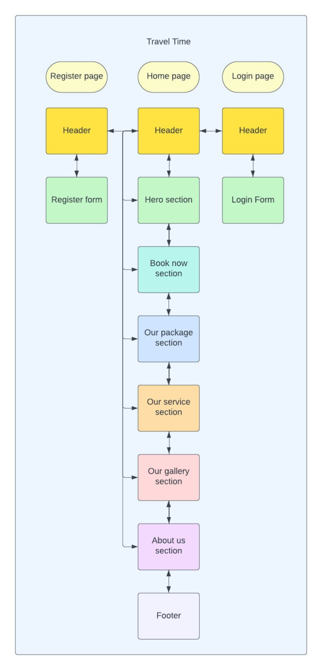

**6. Coding**

Index.html

<!DOCTYPE html>

<html lang="en">

  <head>

    <meta charset="UTF-8" />

    <meta name="viewport" content="width=device-width, initial-scale=1.0" />

    <link rel="stylesheet" href="./css/style.css" />

    <link rel="icon" type="image/x-icon" href="./assets/img/logo.png" />

    <title>Travel Time</title>

  </head>

  <body>

    <header>

      <nav class="top-menu">

        <div class="brand">

          <img src="./assets/img/logo.png" alt="Brand Logo" />

          <span>TravelTime</span>

        </div>

        <ul class="navigation">

          <li><a href="#">Home</a></li>

          <li><a href="#book-now">Book</a></li>

          <li class="dropdown">

            <a href="#packages-sectionn">Packages</a>

            <ul class="dropdown-content">

              <li><a href="#packages-section">Turkey</a></li>

              <li><a href="#packages-section">India</a></li>

              <li><a href="#packages-section">France</a></li>

              <li><a href="#packages-section">Germany</a></li>

            </ul>

          </li>

          <li><a href="#service_section">Services</a></li>

          <li><a href="#gallery">Gallery</a></li>

          <li><a href="#about-us">About</a></li>

        </ul>

        <div class="user-menu">

          <button id="loginBtn" onclick="navigateToNextPage('login');">

            Login

          </button>

          <button id="registerBtn" onclick="navigateToNextPage('register');">

            Register

          </button>

        </div>

      </nav>

    </header>

    <section class="welcome-section">

      <img src="./assets/img/image.jpg" alt="Background Image" />

      <div class="welcome-content">

        <h1>Welcome to Travel Time</h1>

        <h2 id="placeName">Visit Placename</h2>

        <a href="#book-now"><button id="bookNowBtn">Book Now</button></a>

      </div>

    </section>

    <div class="row" id="book-now">

      <div class="half-width">

        <img src="./assets/img/section_two.jpg" alt="Brand Image" />

      </div>

      <div class="half-width">

        <form id="bookingForm">

          <h2>How about a vacation?</h2>

          <p>

            Who doesnt want to go for a vaccation fill the form fast for

            interesting packages.

          </p>

          <div class="form-group">

            <label for="whereTo" class="label">Where to:</label>

            <select id="whereTo" name="whereTo" class="input">

              <option value="turkey">Turkey</option>

              <option value="Japan">Japan</option>

              <option value="Singapore">Singapore</option>

              <option value="Usa">USA</option>

              <option value="paris">Paris</option>

              <option value="newYork">New York</option>

              <!-- Add more options as needed -->

            </select>

          </div>

          <div class="form-group">

            <label for="numberOfPersons" class="label">How Many Persons:</label>

            <input

              type="number"

              id="numberOfPersons"

              name="numberOfPersons"

              min="1"

              class="input"

              placeholder="Enter number of persons"

            />

          </div>

          <div class="form-group">

            <label for="startDate" class="label">Start Date:</label>

            <input

              type="date"

              id="startDate"

              name="startDate"

              min="2023-01-01"

              class="input"

              placeholder="Select start date"

            />

          </div>

          <div class="form-group">

            <label for="endDate" class="label">End Date:</label>

            <input

              type="date"

              id="endDate"

              name="endDate"

              min="2023-01-01"

              class="input"

              placeholder="Select end date"

            />

          </div>

          <div class="form-group">

            <label for="description" class="label">Description:</label>

            <textarea

              id="description"

              name="description"

              minlength="50"

              maxlength="500"

              class="input"

              placeholder="Enter a description"

            ></textarea>

          </div>

          <button type="button" onclick="bookNow()" class="submit-button">

            Book Now

          </button>

        </form>

      </div>

    </div>

    <hr />

    <!-- Section packages -->

    <h2

      id="packages-sectionn"

      style="font-size: 36px; margin-top: 30px; text-align: center"

    >

      <u>Our Famous Packages</u>

    </h2>

    <p style="padding-left: 2%; padding-right: 2%; text-align: justify">

      "Travel Time" offers an unparalleled tour package designed to deliver

      seamless and immersive travel experiences across continents. Our

      meticulously organized tours are a testament to our commitment to

      excellence in every aspect of your journey. <br /><br />

      From the snow-capped mountains of Europe to the vibrant cities of Asia,

      and from the wild savannas of Africa to the stunning landscapes of South

      America, our services span across all continents. We pride ourselves on

      our expertly curated itineraries, accommodating diverse interests and

      preferences. <br /><br />

      Our commitment to excellence is reflected in the precision with which we

      organize every aspect of your travel - from accommodation to

      transportation, sightseeing to leisure activities. We prioritize customer

      satisfaction, ensuring that every traveler feels personally cared for and

      catered to throughout their journey.

      <br /><br />

      Travel Time stands out for its dedication to creating unforgettable

      moments, offering authentic cultural experiences, and fostering

      connections with the world's diverse heritage. With a global network of

      partners and a team of experienced professionals, we ensure that your

      travel experience is not just a trip but a remarkable adventure filled

      with memories that last a lifetime.

    </p>

    <div class="package-section" id="packages-section">

      <!-- Add packages dynamically using JavaScript -->

    </div>

    <hr />

    <!-- Section services -->

    <h2

      id="service_section"

      style="font-size: 36px; margin-top: 30px; text-align: center"

    >

      <u>Our Services</u>

    </h2>

    <p style="padding-left: 2%; padding-right: 2%; text-align: justify">

      As a premier travel agency, we pride ourselves on a range of comprehensive

      services designed to enhance your travel experience. Our offerings include

      affordable hotel accommodations that guarantee comfortable stays at

      budget-friendly prices. Indulge in delightful culinary journeys with our

      diverse selection of local and international cuisines under our Food &

      Drinks service. <br /><br />

      Safety is our utmost priority, and our expert guides ensure a secure and

      enjoyable travel experience through our Safety Guide service. Forget

      transportation hassles, as we take care of all your travel needs,

      arranging seamless transport wherever your journey leads, courtesy of our

      Transport service. <br /><br />

      Worried about unforeseen circumstances? Relax with our Travel Insurance

      service, ensuring peace of mind throughout your trip. Additionally, we

      offer flexibility with our No Cancellation Charges policy, allowing you to

      cancel anytime without worries, and we'll refund you accordingly. Travel

      confidently with us, where convenience, safety, and comfort are our top

      priorities.

    </p>

    <div class="services-slider">

      <div class="slider-container">

        <div class="slides"></div>

      </div>

    </div>

    <hr />

    <!-- Gallery Section -->

    <div class="gallery-section" id="gallery">

      <h2

        id="service_section"

        style="font-size: 36px; margin-top: 30px; text-align: center"

      >

        <u>Our Gallery</u>

      </h2>

      <div class="gallery">

        <img

          src="./assets/img/about1.jpg"

          alt="Image 1"

          class="gallery-image"

        />

        <img

          src="./assets/img/about2.jpg"

          alt="Image 2"

          class="gallery-image"

        />

        <img

          src="./assets/img/about3.jpg"

          alt="Image 1"

          class="gallery-image"

        />

        <img

          src="./assets/img/about4.jpg"

          alt="Image 2"

          class="gallery-image"

        />

        <img

          src="./assets/img/about5.jpg"

          alt="Image 1"

          class="gallery-image"

        />

        <img

          src="./assets/img/about6.jpg"

          alt="Image 2"

          class="gallery-image"

        />

        <img

          src="./assets/img/about7.jpg"

          alt="Image 1"

          class="gallery-image"

        />

        <img

          src="./assets/img/about8.jpg"

          alt="Image 2"

          class="gallery-image"

        />

        <!-- Add more images as needed -->

      </div>

    </div>

    <!-- About Us Section -->

    <div class="about-section" id="about-us">

      <div class="row">

        <div class="about-us-image">

          <img src="./assets/img/logo.png" alt="travel time" />

        </div>

        <div class="half-width">

          <div class="company-info">

            <!-- Company information, establishment, details -->

            <h2>About Travel Time</h2>

            <p>

              "Travel Time, where every journey unveils a story, was founded in

              the spirit of exploring the world and creating timeless memories."

              <b>Ruthu M Patil</b> , the visionary behind Travel Time, once

              remarked,

              <i>"Travel opens the doors to endless possibilities."</i>

              Established in 2005, Travel Time has been a beacon for wanderlust

              enthusiasts, curating bespoke travel experiences that transcend

              ordinary excursions. Our passion for travel is woven into every

              itinerary we craft, ensuring that each journey is a tapestry of

              unique adventures and cultural immersions. <br /><br />

              As a premier travel company specializing in tours and exploration,

              we take pride in our dedication to delivering exceptional service,

              personalized attention, and seamless travel experiences. With a

              team of seasoned professionals and an unwavering commitment to

              customer satisfaction, Travel Time invites you to embark on

              transformative journeys, creating indelible moments that last a

              lifetime. Join us in unraveling the world's wonders, one

              destination at a time.

            </p>

            <!-- Add more details as needed -->

          </div>

        </div>

      </div>

    </div>

    <!-- Footer Section -->

    <footer>

      <div class="footer-content">

        <div class="brand">

          <img

            src="./assets/img/logo.png"

            alt="Brand Logo"

            style="height: 40px; width: 40px"

          />

          <p>Travel Time</p>

        </div>

        <div>

          <a href="#">Privacy Policy</a> <br />

          <a href="#">Terms and conditions</a>

        </div>

        <div class="social-icons">

          <a href="#"

            ><img src="./assets/img/instagram.png" alt="Instagram"

          /></a>

          <a href="#"><img src="./assets/img/facebook.png" alt="Facebook" /></a>

          <a href="#"><img src="./assets/img/twitter.png" alt="Facebook" /></a>

        </div>

      </div>

      <div class="copyright">

        <p>&copy; 2023 Travel Time. All Rights Reserved.</p>

      </div>

    </footer>

    <script src="./js/script.js"></script>

  </body>

</html>

Style.css

body {

  margin: 0;

  padding: 0;

  font-family: system-ui, -apple-system, BlinkMacSystemFont, "Segoe UI", Roboto,

    Oxygen, Ubuntu, Cantarell, "Open Sans", "Helvetica Neue", sans-serif,

    sans-serif;

}

a {

  color: inherit;

  text-decoration: none;

}

header {

  background-color: #f0f5f6;

  color: black;

}

.top-menu {

  display: flex;

  justify-content: space-between;

  align-items: center;

  margin: 0 auto;

}

.brand {

  display: flex;

  align-items: center;

  padding-left: 20px;

}

.brand img {

  width: 130px;

  height: 120px;

  margin-right: 10px;

}

.brand span {

  font-size: 24px;

}

.navigation {

  list-style: none;

  color: black;

  display: flex;

  padding-right: 100px;

}

.navigation li {

  margin: 0 15px;

}

.dropdown {

  position: relative;

}

.dropdown-content {

  display: none;

  position: absolute;

  background-color: #333;

  list-style: none;

  height: 100px;

  padding-left: 0;

}

.navigation li:hover .dropdown-content {

  display: block;

  background-color: transparent;

  padding-top: 20px;

  width: 150px;

}

.user-menu {

  display: flex;

  align-items: center;

  padding-right: 10px;

}

.user-menu button {

  margin: 0 10px;

  padding: 10px 10px;

  background-color: #588298;

  color: #fff;

  border: none;

  cursor: pointer;

  width: 80px;

  border-radius: 10%;

}

.user-menu button:hover {

  background-color: rgb(29, 43, 126);

}

.welcome-section img {

  width: 100%;

  height: 90vh;

  object-fit: fill;

}

.welcome-content {

  position: absolute;

  top: 50%;

  left: 50%;

  transform: translate(-50%, -50%);

  text-align: center;

  color: black;

}

.welcome-content h1 {

  font-size: 36px;

  margin-bottom: 10px;

}

.welcome-content h2 {

  font-size: 48px;

  margin-bottom: 20px;

}

#bookNowBtn {

  padding: 10px 20px;

  background-color: #ff5722;

  border: none;

  color: #fff;

  font-size: 18px;

  cursor: pointer;

  border-radius: 10%;

}

/* second checkpoint */

/* second checkpoint */

.row {

  display: flex;

  width: 100%;

  height: 630px;

}

.half-width {

  flex: 1;

  width: 50%;

  padding-right: 10px;

}

.half-width img {

  width: 100%;

  height: 90%;

  padding-top: 20px;

}

.half-width h2 {

  font-size: 36px;

}

form {

  margin: 0 auto;

  padding: 20px;

  padding-right: 40px;

  font-family: Arial, sans-serif;

}

.form-group {

  margin-bottom: 20px;

}

.label {

  display: block;

  margin-bottom: 5px;

  font-weight: bold;

}

.input {

  width: 100%;

  padding: 8px;

  border: 1px solid #ccc;

  border-radius: 4px;

  transition: border-color 0.3s;

}

.input:focus {

  outline: none;

  border-color: #4caf50;

}

.submit-button {

  background-color: #588298;

  color: white;

  padding: 10px 15px;

  border: none;

  border-radius: 4px;

  cursor: pointer;

  transition: background-color 0.3s;

}

.submit-button:hover {

  background-color: rgb(29, 43, 126);

}

.package-section {

  display: flex;

  flex-wrap: wrap;

  justify-content: space-around;

  margin: 20px 0;

}

.package-section img {

  height: 250px;

  width: 100%;

}

.rating {

  font-size: 0;

  padding-bottom: 10px;

}

.rating span {

  font-size: 30px;

  color: #ffd700;

  /* Default star color */

  cursor: pointer;

}

.rating span:hover,

.rating span:hover ~ span {

  color: #ffb400;

  /* Color on hover */

}

/* Change the color of filled stars */

.rating .filled-star {

  color: gold;

  /* Change this to the desired color */

}

/* Change the color of empty stars (if necessary) */

.rating .empty-star {

  color: #ccc;

  /* Change this to the desired color */

}

.package-card {

  width: 300px;

  margin: 10px;

  padding: 15px;

  border: 1px solid #ccc;

  justify-content: center;

  text-align: center;

  padding: 10px;

  box-shadow: 10px 10px 5px #f7f0f0;

}

.package-card button {

  background-color: #588298;

  color: white;

  padding: 10px 15px;

  border: none;

  border-radius: 4px;

  cursor: pointer;

  transition: background-color 0.3s;

}

/* Styles for Services Section */

.services-slider {

  display: flex;

  justify-content: center;

  padding-bottom: 2%;

}

.slider-container {

  overflow: hidden;

  position: relative;

  width: 660px;

}

.slides {

  transition: transform 0.5s ease;

}

.slide {

  flex: 0 0 16.666%;

  padding: 20px;

  text-align: center;

}

.serviceImage {

  height: 120px;

  width: 120px;

}

/* Additional styling for service card */

.slide {

  background-image: url("../assets/img/bg_service.jpg");

  border-radius: 8px;

  margin: 10px;

  box-shadow: 0 4px 8px rgba(0, 0, 0, 0.1);

  background-repeat: no-repeat;

  background-size: cover;

  background-position: center;

  color: rgb(92, 99, 198);

  font-size: 24px;

}

.slide h3 {

  margin-bottom: 10px;

}

.slide p {

  font-size: 20px;

}

/* checkpoint 3 CSS */

/* Gallery Section */

.gallery-section {

  padding: 20px 8%;

  margin-top: 40px;

  background-image: url("../assets/img/gallery_bg.jpg");

  background-size: cover;

  color: white;

}

.gallery {

  display: flex;

  justify-content: space-around;

  flex-wrap: wrap;

  padding-bottom: 20px;

}

.gallery-image {

  padding: 10px 2px;

  position: relative;

  cursor: pointer;

  overflow: hidden;

  width: 250px;

  height: 200px;

  object-fit: cover;

  opacity: 0;

  transition: opacity 0.5s ease-in-out;

}

.gallery-image.show {

  opacity: 1;

}

.gallery-image:hover {

  transform: scale(1.1);

}

/* About Us Section */

.about-section .row {

  display: flex;

  width: 100%;

  height: 490px;

}

.about-us-image {

  display: flex;

  justify-content: center;

  align-items: center;

  width: 50%;

}

.about-us-image img {

  width: 0;

  transition: width 1.5s ease;

}

/* Footer Section */

footer {

  background-color: #f0f5f6;

  color: #0b0909;

  text-align: center;

  padding: 20px 0;

}

.footer-content {

  display: flex;

  justify-content: space-between;

  align-items: center;

  max-width: 1200px;

  margin: 0 auto;

}

.brand {

  width: 160px;

}

.brand p {

  font-size: 18px;

}

.social-icons img {

  width: 30px;

  height: 30px;

  margin-left: 10px;

}

Script.js

const placeNames = ["Japan", "South Korea", "Canada", "Belgium", "Zimbabwe"];

let index = 0;

const placeNameElement = document.getElementById("placeName");

function changePlaceName() {

  placeNameElement.textContent = `Visit ${placeNames[index]}`;

  index = (index + 1) % placeNames.length;

}

setInterval(changePlaceName, 200);

document.getElementById("bookNowBtn").addEventListener("click", () => {

  // Handle the "Book Now" button click event

});

document.getElementById("loginBtn").addEventListener("click", () => {

  // Handle the "Login" button click event

});

document.getElementById("registerBtn").addEventListener("click", () => {

  // Handle the "Register" button click event

});

// second checkpoint scripts below

// Set the minimum date for the start date input to today

document.getElementById('startDate').min = new Date().toISOString().split('T')[0];

// Set the minimum date for the end date input to the selected start date

document.getElementById('startDate').addEventListener('change', function () {

  document.getElementById('endDate').min = this.value;

});

function bookNow() {

  // Get all input elements in the form

  var inputs = document.getElementById('bookingForm').getElementsByTagName('input');

  var selects = document.getElementById('bookingForm').getElementsByTagName('select');

  var textareas = document.getElementById('bookingForm').getElementsByTagName('textarea');

  // Check if all inputs are filled

  var isValid = true;

  for (var i = 0; i < inputs.length; i++) {

    if (inputs[i].type !== 'button' && inputs[i].value === '') {

      isValid = false;

      break;

    }

  }

  // Check if all selects are filled

  for (var i = 0; i < selects.length; i++) {

    if (selects[i].value === '') {

      isValid = false;

      break;

    }

  }

  // Check if all textareas are filled

  for (var i = 0; i < textareas.length; i++) {

    if (textareas[i].value === '') {

      isValid = false;

      break;

    }

  }

  // Display alert based on validation result

  if (isValid) {

    alert('Booking successful');

  } else {

    alert('Please fill in all fields');

  }

}

// Sample data for packages

var packages = [

  { image: "./assets/img/newzeland.jpg", name: "New Zealand", attractions: "Pristine nature, breathtaking scenery, and adventure opportunities make New Zealand a haven for outdoor enthusiasts.", price: "$600", rating: "4" },

  { image: "./assets/img/india.jpg", name: "India", attractions: "Vibrant culture, diverse landscapes, and rich heritage make India a captivating destination for travelers worldwide.", price: "$500", rating: "5" },

  { image: "./assets/img/south_korea.jpg", name: "South Korea", attractions: "Blend of modernity and tradition, South Korea offers dynamic cities, ancient temples, and delectable cuisine.", price: "$700", rating: "4" },

  { image: "./assets/img/argentina.jpg", name: "Argentina", attractions: " Tango rhythms, stunning landscapes, and a passion for football encapsulate Argentina's vibrant essence.", price: "$1200", rating: "3" },

  { image: "./assets/img/england.jpg", name: "England", attractions: "Historical landmarks, royal traditions, and cultural diversity define England's timeless appeal.", price: "$300", rating: "4" },

  { image: "./assets/img/germany.jpg", name: "Germany", attractions: "Known for efficiency, picturesque landscapes, and a rich history, Germany boasts a unique blend of old-world charm and innovation.", price: "$500", rating: "4" },

  { image: "./assets/img/kenya.jpg", name: "Kenya", attractions: " Home to diverse wildlife, stunning savannas, and vibrant culture, Kenya offers unforgettable safari experiences.", price: "$200", rating: "3" },

  { image: "./assets/img/france.jpg", name: "France", attractions: " Iconic landmarks, exquisite cuisine, and artistic allure define France's charm and cultural magnificence.", price: "$3440", rating: "4" },

  { image: "./assets/img/turkey.jpg", name: "Turkey", attractions: " Bridging East and West, Turkey entices with ancient ruins, vibrant bazaars, and scenic coastlines.", price: "$500", rating: "4" },

];

// Dynamically populate packages and services

document.addEventListener("DOMContentLoaded", function () {

  var packageSection = document.querySelector(".package-section");

  packages.forEach(function (package) {

    var card = createPackageCard(package);

    packageSection.appendChild(card);

  });

});

// function to map the packages card to dom element

function createPackageCard(package) {

  var card = document.createElement("div");

  card.classList.add("package-card");

  var image = document.createElement("img");

  image.src = package.image;

  image.alt = package.name;

  var heading = document.createElement("h3");

  heading.textContent = package.name;

  var paragraph = document.createElement("p");

  paragraph.textContent = package.attractions;

  var price = document.createElement("p");

  price.textContent = "Price: " + package.price;

  var rating = document.createElement("div");

  rating.classList.add("rating");

  rating.innerHTML = generateStarRating(package.rating);

  var bookNowBtn = document.createElement("button");

  bookNowBtn.textContent = "Book Now";

  card.appendChild(image);

  card.appendChild(heading);

  card.appendChild(paragraph);

  card.appendChild(price);

  card.appendChild(rating);

  card.appendChild(bookNowBtn);

  return card;

}

// Function to generate star icons based on the rating

function generateStarRating(rating) {

  var stars = '';

  for (var i = 0; i < 5; i++) {

    if (i < rating) {

      stars += '<span class="filled-star">★</span>'; // filled star

    } else {

      stars += '<span class="empty-star">☆</span>'; // Empty star

    }

  }

  return stars;

}

// Getting services data

var services = [

  { name: "Affordable Hotel", description: "Comfortable stays at budget-friendly prices" },

  { name: "Food & Drinks", description: "Delicious local and international cuisines" },

  { name: "Safety Guide", description: "Expert guides ensuring a safe and enjoyable experience" },

  { name: "Transport", description: "We will arrange all transport for your travel wherever you want" },

  { name: "Travel insurance", description: "No need to worry about your travel problems" },

  { name: "No cancellation charges", description: "Cancel anytime and we refund you" },

];

// Function to create service slides

function createServiceSlide(service) {

  const slide = document.createElement("div");

  slide.classList.add("slide");

  const serviceImage = document.createElement("img");

  serviceImage.alt = "service image";

  serviceImage.src = "./assets/img/service_img.svg"

  serviceImage.classList.add("serviceImage");

  const serviceName = document.createElement("h3");

  serviceName.textContent = service.name;

  const serviceDescription = document.createElement("p");

  serviceDescription.textContent = service.description;

  slide.appendChild(serviceImage);

  slide.appendChild(serviceName);

  slide.appendChild(serviceDescription);

  return slide;

}

// Display services in the slider

document.addEventListener("DOMContentLoaded", function () {

  const slidesContainer = document.querySelector(".slides");

  services.forEach(function (service) {

    const slide = createServiceSlide(service);

    slidesContainer.appendChild(slide);

  });

  const slides = document.querySelectorAll(".slide");

  let slideIndex = 0;

  const totalSlides = slides.length;

  function showSlides() {

    slides.forEach((slide) => {

      slide.style.display = "none";

    });

    slides[slideIndex].style.display = "block";

  }

  function slideInterval() {

    slideIndex++;

    if (slideIndex >= totalSlides) {

      slideIndex = 0;

    }

    showSlides();

  }

  showSlides();

  setInterval(slideInterval, 3000); // Change slide every 3 seconds

});

// checkpoint 3 js starts here

// Function to check if an element is in the viewport

function isInViewport(element) {

  const rect = element.getBoundingClientRect();

  return (

    rect.top >= 0 &&

    rect.left >= 0 &&

    rect.bottom <= (window.innerHeight || document.documentElement.clientHeight) &&

    rect.right <= (window.innerWidth || document.documentElement.clientWidth)

  );

}

// Function to add the 'show' class when the image is in the viewport

function showImage() {

  const galleryImages = document.querySelectorAll('.gallery-image');

  galleryImages.forEach((image, index) => {

    if (isInViewport(image)) {

      setTimeout(() => {

        image.classList.add('show');

      }, index * 200); // Adjust the delay timing as needed

    }

  });

}

function showAboutUsImage() {

  const images = document.getElementById('about-us');

  if (isInViewport(images)) {

    setTimeout(() => {

      const image = images.querySelector('img');

      image.style.width = '50%'; // Set width to 100% to scale up gradually

    }, index * 200);

  }

}

// Event listener for scrolling

window.addEventListener('scroll', showImage);

window.addEventListener('scroll', showAboutUsImage);

// Initial check on page load

showImage();

showAboutUsImage();

function navigateToNextPage(pageName) {

  let destinationPage;

  // Determine the destination page based on the parameter

  if (pageName === 'register') {

    destinationPage = 'register.html';

  } else if (pageName === 'login') {

    destinationPage = 'login.html';

  } else if (pageName === 'home') {

    destinationPage = 'home.html';

  } else {

    // Default to a specific page when an unknown parameter is passed

    destinationPage = 'default.html';

  }

  // Navigate to the determined page

  window.location.href = destinationPage;

}

.

Register.html

<html lang="en">

  <head>

    <meta charset="UTF-8" />

    <meta name="viewport" content="width=device-width, initial-scale=1.0" />

    <link rel="stylesheet" href="./css/register.css" />

    <link rel="stylesheet" href="./css/style.css" />

    <title>Register</title>

  </head>

  <body>

    <!-- header section -->

    <header>

      <nav class="top-menu">

        <div class="brand">

          <img src="./assets/img/logo.png" alt="Brand Logo" />

          <span>TravelTime</span>

        </div>

        <ul class="navigation">

          <li><a href="index.html">Home</a></li>

          <li><a href="#book-now">Book</a></li>

          <li class="dropdown">

            <a href="#packages-section">Packages</a>

            <ul class="dropdown-content">

              <li><a href="#packages-section">Tokyo</a></li>

              <li><a href="#packages-section">India</a></li>

              <li><a href="#packages-section">Paris</a></li>

              <li><a href="#packages-section">Dubai</a></li>

              <li><a href="#packages-section">More</a></li>

            </ul>

          </li>

          <li><a href="#services-section">Services</a></li>

          <li><a href="#gallery">Gallery</a></li>

          <li><a href="#about-us">About</a></li>

        </ul>

        <div class="user-menu">

          <button id="loginBtn" onclick="navigateToNextPage('login');">

            Login

          </button>

          <button id="registerBtn" onclick="navigateToNextPage('register');">

            Register

          </button>

        </div>

      </nav>

    </header>

    <div class="container">

      <div class="brand-register">

        <img src="./assets/img/logo.png" alt="Brand Logo" />

      </div>

      <h2>Register at Travel Time</h2>

      <form id="registerForm" onsubmit="return validateForm()">

        <input type="text" id="fullname" placeholder="Full Name" required />

        <input type="text" id="contact" placeholder="Contact Num" required />

        <input type="date" id="dob" required />

        <input type="email" id="email" placeholder="Email" required />

        <input type="password" id="password" placeholder="Password" required />

        <label for="gender">Gender:</label>

        <select id="gender" required>

          <option value="male">Male</option>

          <option value="female">Female</option>

          <option value="other">Other</option>

        </select>

        <button type="submit">Register</button>

      </form>

      <p>

        Already have an account? <a href="login.html"><b>Login here</b></a>

      </p>

    </div>

    <script src="./js/register.js"></script>

    <script src="./js/script.js"></script>

  </body>

</html>

Register.css

/* Add your CSS styling for the registration form */

/* Example styles */

body {

  background-color: #f0f5f6;

}

.container {

  width: 80%;

  max-width: 400px;

  margin: 10px auto;

  padding: 20px;

  border: 1px solid #ccc;

  border-radius: 5px;

  text-align: center;

  background-color: white;

}

.brand-register img {

  width: 80px;

  height: 90px;

  align-items: center;

}

h2 {

  margin-bottom: 20px;

}

input,

select,

button {

  display: block;

  width: 100%;

  margin-bottom: 10px;

  padding: 8px;

}

#registerForm {

  padding: 8px;

  border: 1px solid #ccc;

  border-radius: 4px;

  transition: border-color 0.3s;

}

button {

  background-color: #007bff;

  color: #fff;

  border: none;

  cursor: pointer;

}

input[type="date"] {

  font-family: Arial, sans-serif;

}

button:hover {

  background-color: #0056b3;

}

p {

  margin-top: 20px;

}

Register.js

const placeNames = ["Paris", "New York", "Tokyo", "Sydney", "London"];

let index = 0;

const placeNameElement = document.getElementById("placeName");

function changePlaceName() {

    placeNameElement.textContent = `Visit ${placeNames[index]}`;

    index = (index + 1) % placeNames.length;

}

setInterval(changePlaceName, 200);

document.getElementById("bookNowBtn").addEventListener("click", () => {

    // Handle the "Book Now" button click event

});

document.getElementById("loginBtn").addEventListener("click", () => {

    // Handle the "Login" button click event

});

document.getElementById("registerBtn").addEventListener("click", () => {

    // Handle the "Register" button click event

});

// second checkpoint

// Set the minimum date for the start date input to today

document.getElementById('startDate').min = new Date().toISOString().split('T')[0];

// Set the minimum date for the end date input to the selected start date

document.getElementById('startDate').addEventListener('change', function () {

    document.getElementById('endDate').min = this.value;

});

function bookNow() {

    // Get all input elements in the form

    var inputs = document.getElementById('bookingForm').getElementsByTagName('input');

    var selects = document.getElementById('bookingForm').getElementsByTagName('select');

    var textareas = document.getElementById('bookingForm').getElementsByTagName('textarea');

    // Check if all inputs are filled

    var isValid = true;

    for (var i = 0; i < inputs.length; i++) {

        if (inputs[i].type !== 'button' && inputs[i].value === '') {

            isValid = false;

            break;

        }

    }

    // Check if all selects are filled

    for (var i = 0; i < selects.length; i++) {

        if (selects[i].value === '') {

            isValid = false;

            break;

        }

    }

    // Check if all textareas are filled

    for (var i = 0; i < textareas.length; i++) {

        if (textareas[i].value === '') {

            isValid = false;

            break;

        }

    }

    // Display alert based on validation result

    if (isValid) {

        alert('Booking successful');

    } else {

        alert('Please fill in all fields');

    }

}

// Sample data for packages

var packages = [

    { image: "./assets/img/tokyo.jpg", name: "Tokyo", attractions: "Tokyo is the administrative, cultural, financial, commercial, and educational centre of Japan and the focus of an extensive urban complex that includes Kawasaki and Yokohama.", price: "$600", rating: "4.5" },

    { image: "./assets/img/india.jpg", name: "India", attractions: "India is part of the continent of Asia. Most of India forms a peninsula, which means it is surrounded by water on three sides. ", price: "$500", rating: "5.0" },

    { image: "./assets/img/paris.jpg", name: "Paris", attractions: "Paris has been one of the world's major centres of finance, diplomacy, commerce, culture, fashion, gastronomy and many areas.", price: "$700", rating: "4.5" },

    { image: "./assets/img/dubai.jpg", name: "Dubai", attractions: "Known as the “capital of UAE's economy,” Dubai is a key financial and trading hub, and one of the fastest growing cities in the world.", price: "$1200", rating: "8.0" },

    { image: "./assets/img/indonesia.jpg", name: "Indonesia", attractions: "Indonesia is the largest country in Southeast Asia, with a maximum dimension from east to west of about 3,200 miles (5,100 km) and an extent from north to south of 1,100 miles (1,800 km)", price: "$300", rating: "4.3" },

    { image: "./assets/img/germany.jpg", name: "Germany", attractions: "Germany's central and southern regions have forested hills and mountains cut through by the Danube, Main, and Rhine river valleys.", price: "$500", rating: "4.5" },

    { image: "./assets/img/zimbabwe.jpg", name: "Africa", attractions: "Africa, the second-largest continent, is bounded by the Mediterranean Sea, the Red Sea, the Indian Ocean, and the Atlantic Ocean.", price: "$200", rating: "3.5" },

    { image: "./assets/img/russia.jpg", name: "Russia", attractions: "Russia, the largest country in the world, occupies one-tenth of all the land on Earth. It spans 11 time zones across two continents (Europe and Asia) and has coasts on three oceans (the Atlantic, Pacific, and Arctic).", price: "$3440", rating: "7.5" },

    { image: "./assets/img/spain.jpg", name: "Spain", attractions: "Although there is a national parliament, Spain is one of the most decentralized democracies in Europe. Each of its 17 regions manages its own schools, hospitals, and other public services.", price: "$500", rating: "4.5" },

];

// Sample data for services

var services = [

    { name: "Affordable Hotel", description: "Comfortable stays at budget-friendly prices" },

    { name: "Food & Drinks", description: "Delicious local and international cuisines" },

    { name: "Safety Guide", description: "Expert guides ensuring a safe and enjoyable experience" },

    { name: "Transport", description: "We will arrange all transport for your travel where ever you want" },

    { name: "Travek insurance", description: "No need to worry about your travel problems" },

    { name: "No cancellation charges", description: "Cancel anytime and we refund you" },

];

// Dynamically populate packages and services

document.addEventListener("DOMContentLoaded", function () {

    var packageSection = document.querySelector(".package-section");

    packages.forEach(function (package) {

        var card = createPackageCard(package);

        packageSection.appendChild(card);

    });

    var servicesSection = document.querySelector(".services-section");

    services.forEach(function (service) {

        var card = createServiceCard(service);

        servicesSection.appendChild(card);

    });

});

// function to map the packages card to dom element

function createPackageCard(package) {

    var card = document.createElement("div");

    card.classList.add("package-card");

    var image = document.createElement("img");

    image.src = package.image;

    image.alt = package.name;

    var heading = document.createElement("h3");

    heading.textContent = package.name;

    var paragraph = document.createElement("p");

    paragraph.textContent = package.attractions;

    var price = document.createElement("p");

    price.textContent = "Price: " + package.price;

    var rating = document.createElement("p");

    rating.textContent = "Rating: " + package.rating;

    var bookNowBtn = document.createElement("button");

    bookNowBtn.textContent = "Book Now";

    card.appendChild(image);

    card.appendChild(heading);

    card.appendChild(paragraph);

    card.appendChild(price);

    card.appendChild(rating);

    card.appendChild(bookNowBtn);

    return card;

}

// function to map service card to dom element

function createServiceCard(service) {

    var card = document.createElement("div");

    card.classList.add("service-card");

    var heading = document.createElement("h3");

    heading.textContent = service.name;

    var paragraph = document.createElement("p");

    paragraph.textContent = service.description;

    card.appendChild(heading);

    card.appendChild(paragraph);

    return card;

}

// checkpoint 3 js starts here

// Function to check if an element is in the viewport

function isInViewport(element) {

    const rect = element.getBoundingClientRect();

    return (

        rect.top >= 0 &&

        rect.left >= 0 &&

        rect.bottom <= (window.innerHeight || document.documentElement.clientHeight) &&

        rect.right <= (window.innerWidth || document.documentElement.clientWidth)

    );

}

// Function to add the 'show' class when the image is in the viewport

function showImage() {

    const galleryImages = document.querySelectorAll('.gallery-image');

    galleryImages.forEach((image, index) => {

        if (isInViewport(image)) {

            setTimeout(() => {

                image.style.transition = `opacity 0.5s ease-in-out`;

                image.style.opacity = 1;

            }, index * 200); // Adjust the delay timing as needed

        }

    });

}

function showAboutUsImage() {

    const images = document.getElementById('about-us');

    if (isInViewport(images)) {

        setTimeout(() => {

            const image = images.querySelector('img');

            image.style.width = '50%'; // Set width to 100% to scale up gradually

        }, index * 200);

    }

}

// Event listener for scrolling

window.addEventListener('scroll', showImage);

window.addEventListener('scroll', showAboutUsImage);

// Initial check on page load

showImage();

showAboutUsImage();

function navigateToNextPage(pageName) {

    let destinationPage;

    // Determine the destination page based on the parameter

    if (pageName === 'register') {

        destinationPage = 'register.html';

    } else if (pageName === 'login') {

        destinationPage = 'login.html';

    } else if (pageName === 'home') {

        destinationPage = 'home.html';

    } else {

        // Default to a specific page when an unknown parameter is passed

        destinationPage = 'default.html';

    }

    // Navigate to the determined page

    window.location.href = destinationPage;

}

Login.html

<html lang="en">

  <head>

    <meta charset="UTF-8" />

    <meta name="viewport" content="width=device-width, initial-scale=1.0" />

    <link rel="stylesheet" href="./css/register.css" />

    <link rel="icon" type="image/x-icon" href="./assets/img/logo.png" />

    <link rel="stylesheet" href="./css/style.css" />

    <title>Document</title>

  </head>

  <body>

    <!-- header section -->

    <header>

      <nav class="top-menu">

        <div class="brand">

          <img src="./assets/img/logo.png" alt="Brand Logo" />

          <span>TravelTime</span>

        </div>

        <ul class="navigation">

          <li><a href="index.html">Home</a></li>

          <li><a href="#book-now">Book</a></li>

          <li class="dropdown">

            <a href="#packages-section">Packages</a>

            <ul class="dropdown-content">

              <li><a href="#packages-section">Tokyo</a></li>

              <li><a href="#packages-section">India</a></li>

              <li><a href="#packages-section">Paris</a></li>

              <li><a href="#packages-section">Dubai</a></li>

              <li><a href="#packages-section">More</a></li>

            </ul>

          </li>

          <li><a href="#services-section">Services</a></li>

          <li><a href="#gallery">Gallery</a></li>

          <li><a href="#about-us">About</a></li>

        </ul>

        <div class="user-menu">

          <button id="loginBtn" onclick="navigateToNextPage('login');">

            Login

          </button>

          <button id="registerBtn" onclick="navigateToNextPage('register');">

            Register

          </button>

        </div>

      </nav>

    </header>

    <div class="container">

      <div class="brand-register">

        <img src="./assets/img/logo.png" alt="Brand Logo" />

      </div>

      <h2>Login To Travel Time</h2>

      <form id="registerForm" onsubmit="return validateForm()">

        <input type="email" id="emaild" placeholder="Your Email" required />

        <input

          type="password"

          id="password"

          placeholder="Enter your password"

          required

        />

        <button type="submit">Login</button>

      </form>

      <p>

        New to Travel Time? <a href="register.html"><b>Register here</b></a>

      </p>

    </div>

    <script src="./js/register.js"></script>

    <script src="./js/script.js"></script>

  </body>

</html>

**7. Output**

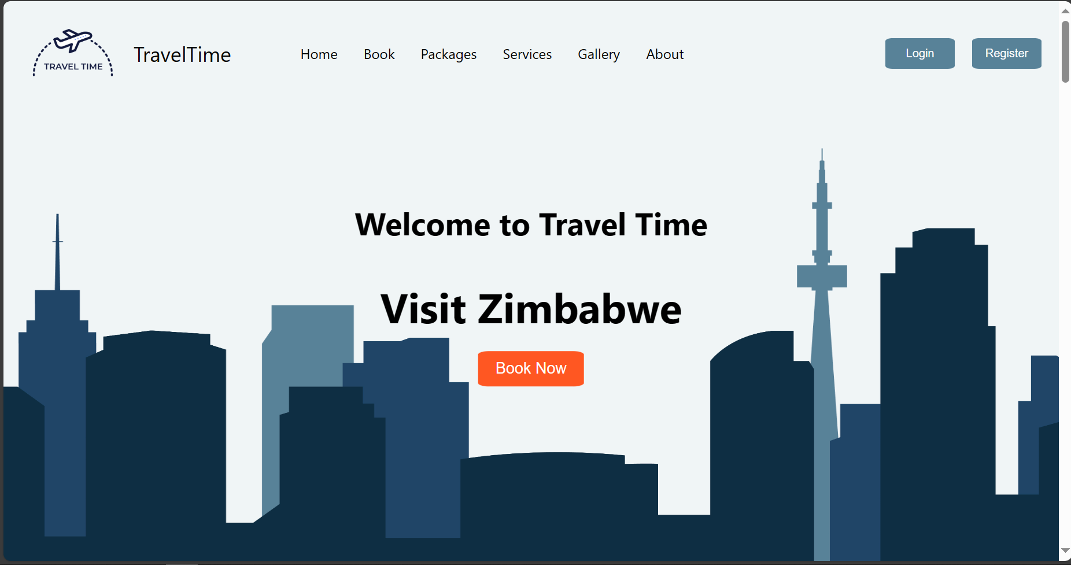

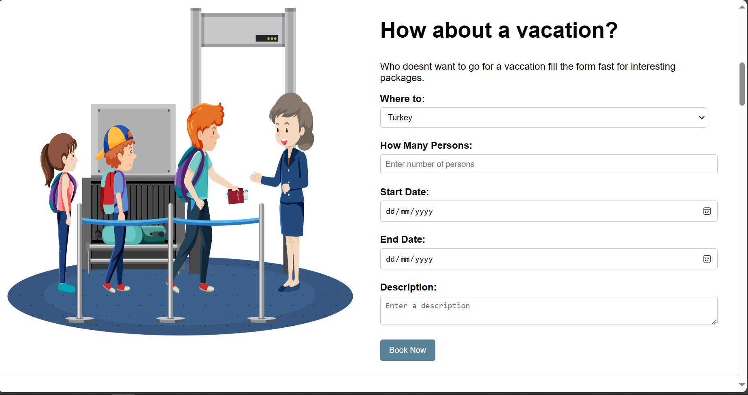

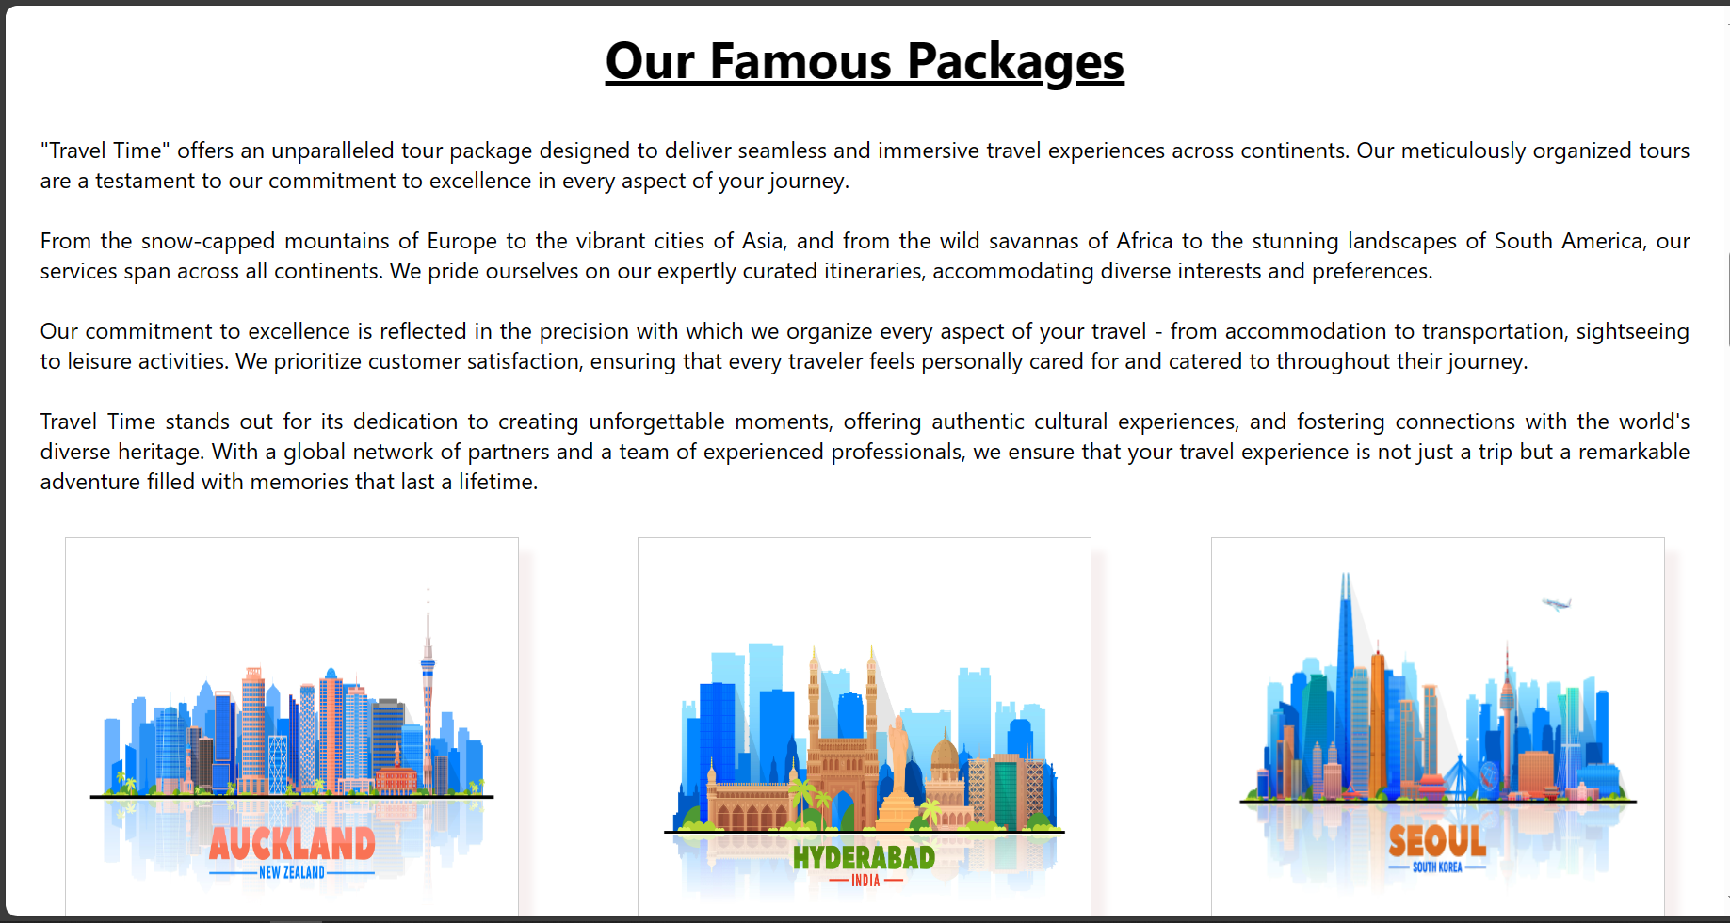

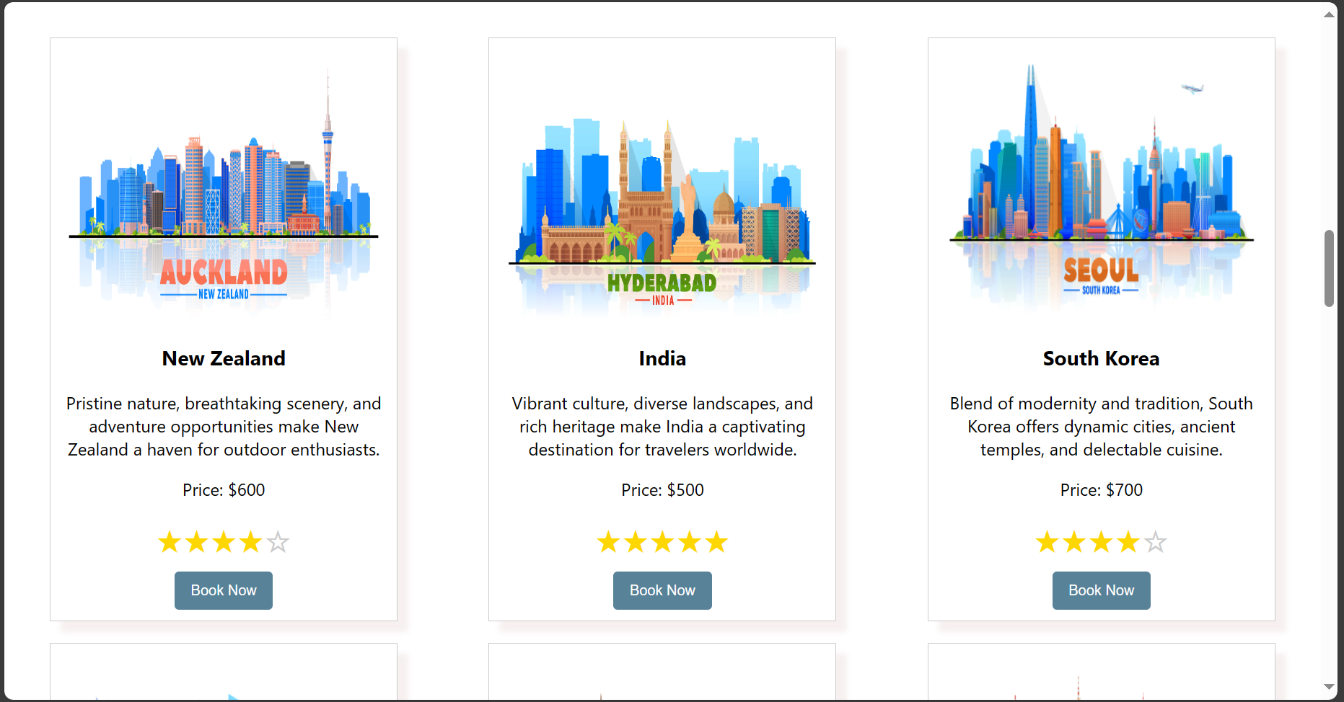

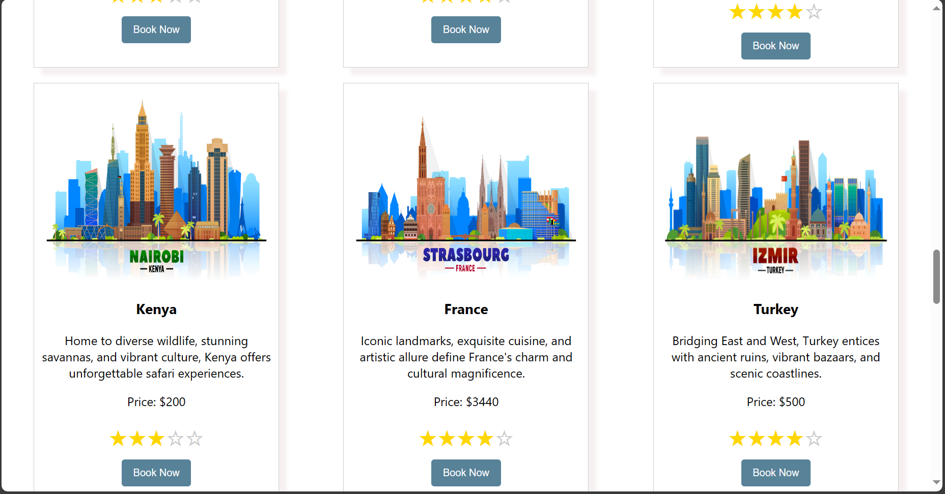

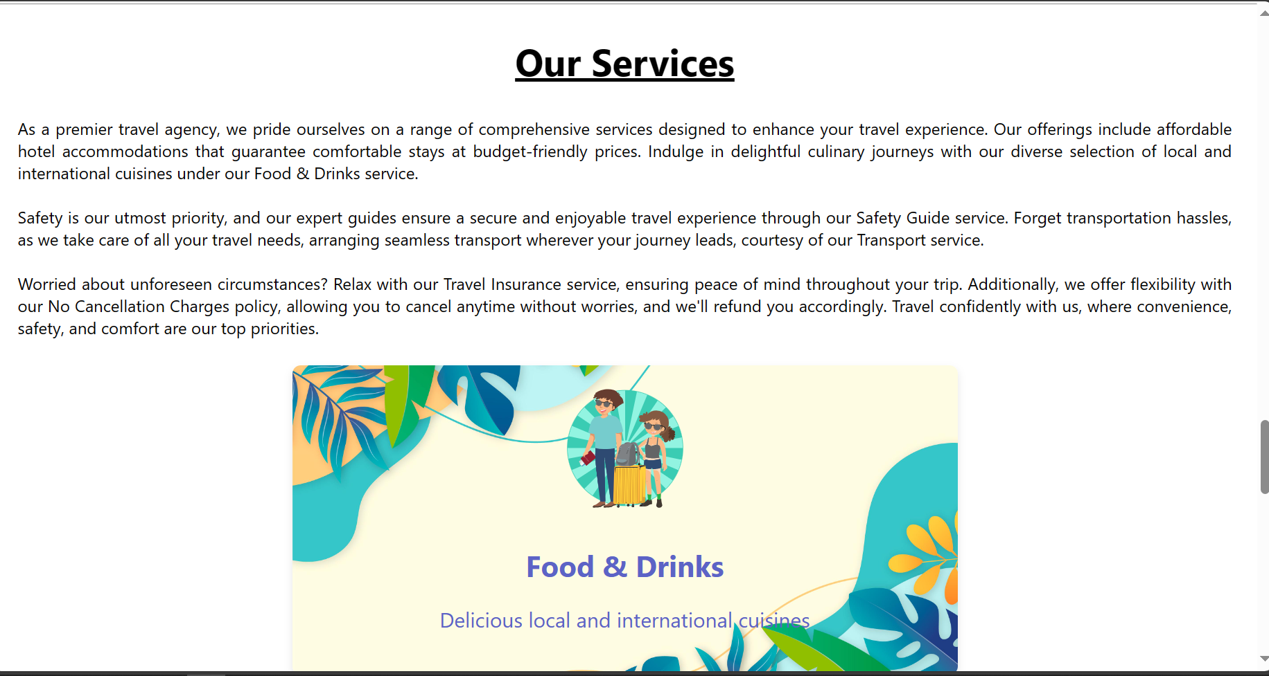

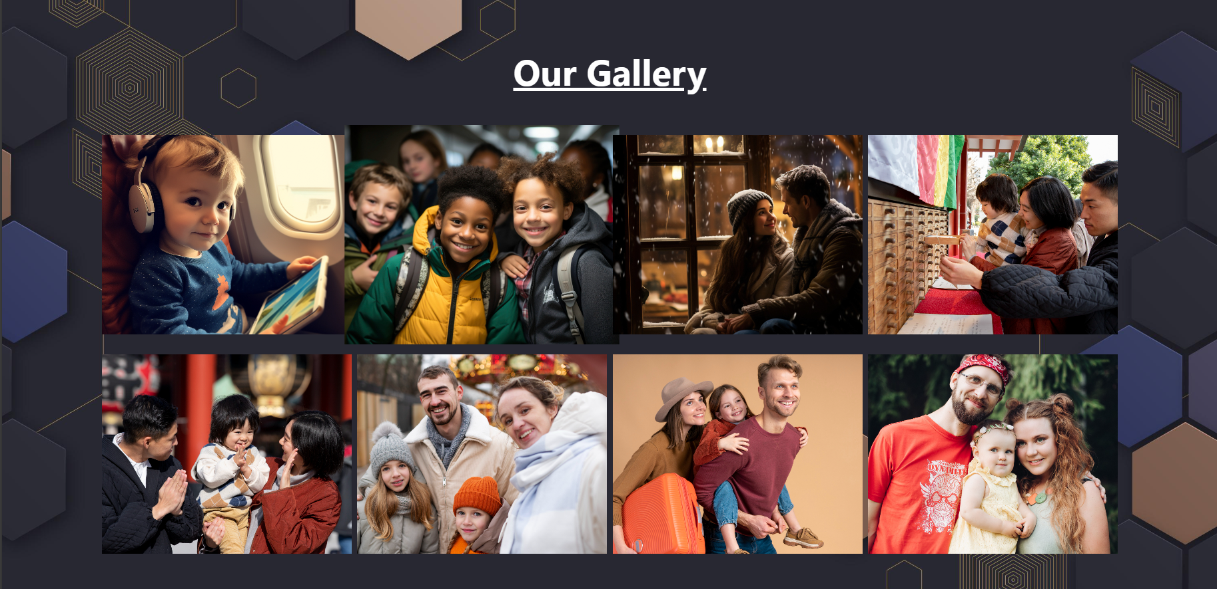

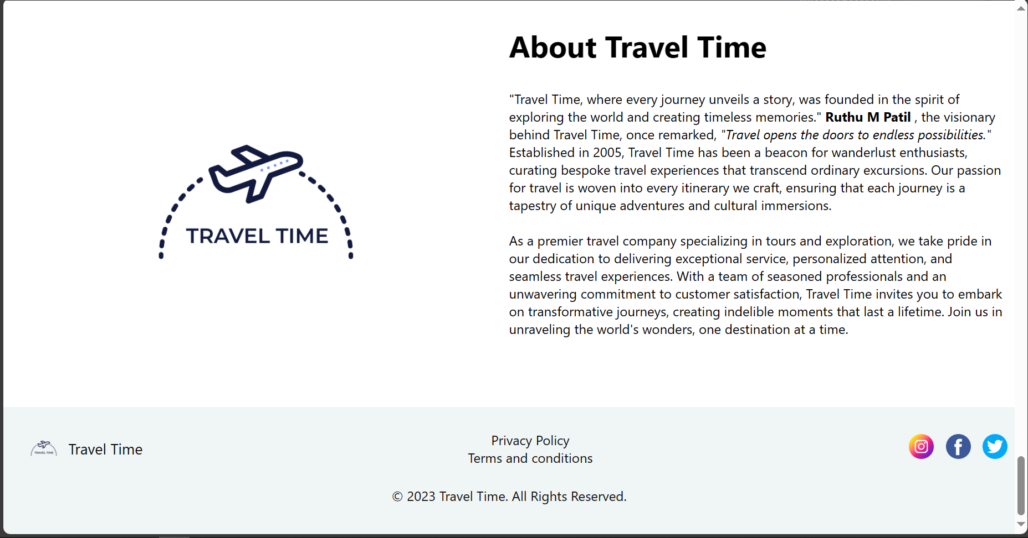

Login page

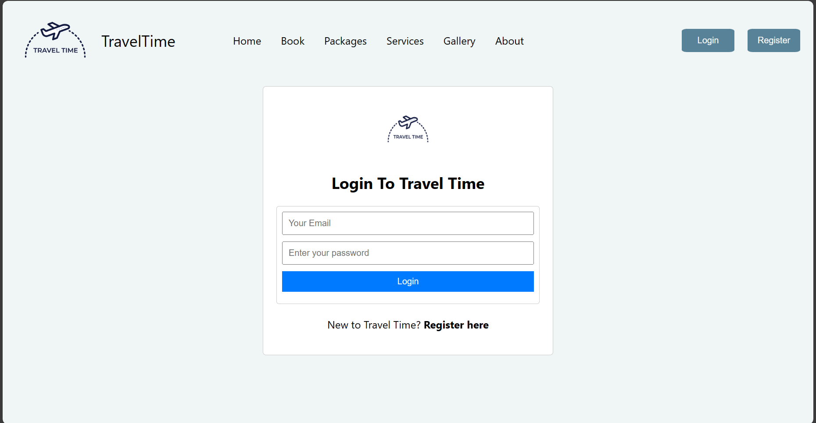

Register page

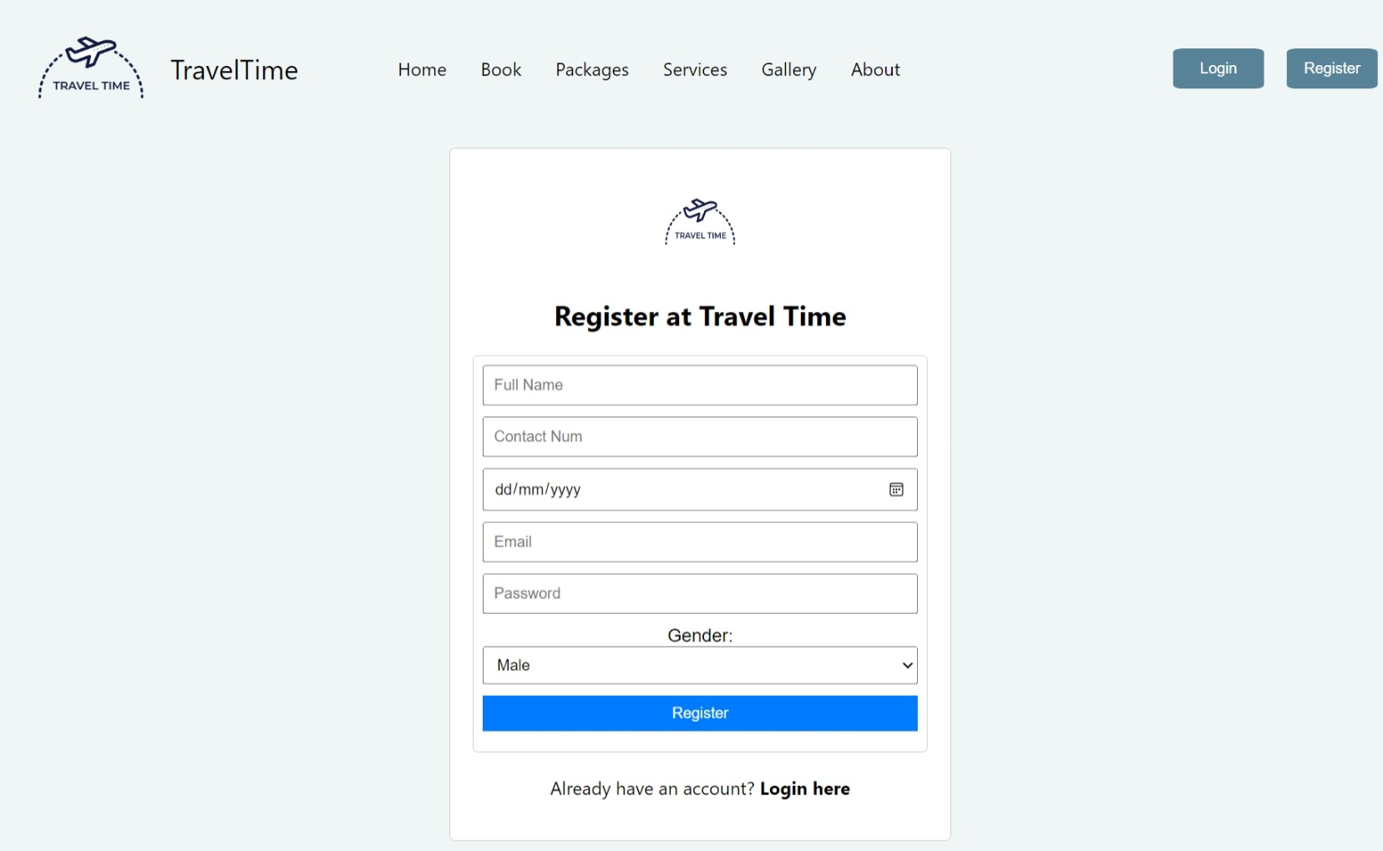

**8. Validation**

Validation substantiates the welcoming and visually engaging design of the homepage, capturing users' attention upon entry. The user-friendly navigation menu is noted for facilitating seamless access to vital sections, and its effectiveness extends to the dropdown feature within the Packages menu, offering a diverse array of options for multiple destinations. Additionally, validation affirms the flawless functionality of the booking section, allowing users to effortlessly select destinations, specify travel details, and successfully complete reservations.

Furthermore, the Package Gallery is verified to proficiently showcase travel packages in a card format, presenting destination images, comprehensive descriptions, USD prices, ratings, and accessible booking options. Coding, debugging, and testing are efficiently executed using development tools such as Visual Studio and Chrome. Lastly, validation ensures consistent website performance across various web browsers, including Chrome and Edge.

**9. Conclusion**

In summary, the development journey of the travel booking website has been both rewarding and educational. The primary objective of this project was to craft a user-friendly platform utilizing HTML, CSS, and JavaScript to facilitate smooth travel planning and booking experiences. Throughout the developmental phase, numerous significant insights and accomplishments have come to fruition.

First and foremost, the incorporation of responsive design principles through CSS guarantees the website's accessibility and functionality across a spectrum of devices, ensuring users a consistent and enjoyable browsing experience. Leveraging JavaScript has facilitated dynamic features, elevating user interaction and simplifying the booking process.

Reflecting on this project, it not only refined technical skills in web development but also underscored the importance of prioritizing user experience and fostering continuous improvement. As technology advances, so does the potential to enhance the functionality and features of the travel booking website. Future iterations may encompass additional features, heightened security measures, and further optimization for enhanced performance.

Fundamentally, the travel booking website project emerges as a valuable learning experience that seamlessly combines technical expertise with a user-centric approach. With the dynamic evolution of the digital landscape, the skills acquired during this project stand as a robust foundation, poised to contribute to future ventures in web development.

**10. References**

* Chat GPT: Explore the capabilities of ChatGPT at <https://chat.openai.com/>
* HTML: Enhance your HTML skills with insights from <https://www.w3schools.com/html/>
* CSS: Dive into the world of CSS with practical examples from <https://www.w3schools.com/css/> Tutorial.
* JavaScript: Expand your knowledge of JavaScript with tutorials from <https://www.w3schools.com/js/>.
* Free Pik: Access a diverse collection of free design resources at <https://www.freepik.com/>, including graphics, vectors, and photos.
* Git: Explore Git and version control through the <https://git-scm.com/book/en/v2>